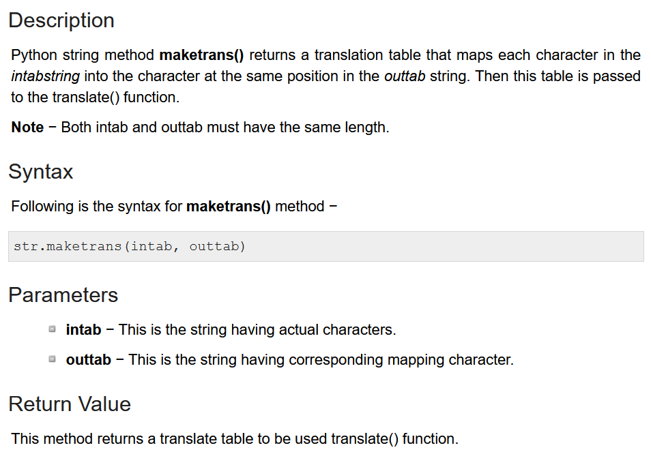  
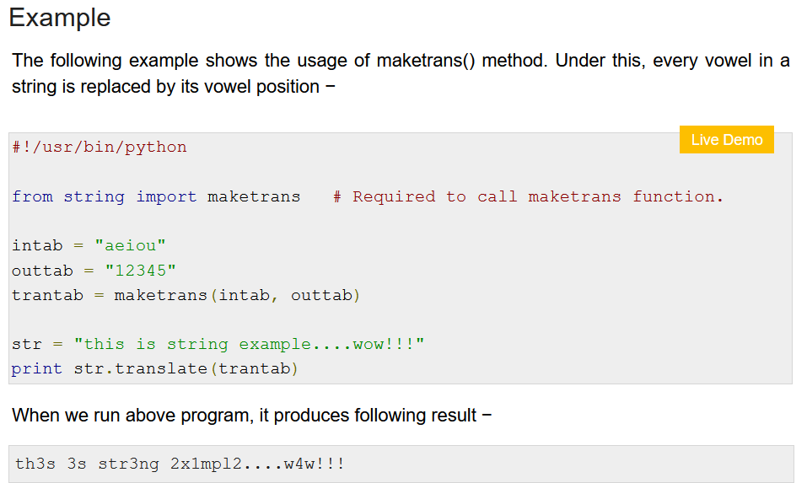

NLP concepts

Traditional NLP  
Modern NLP 🡪 Starts from RNN

CountVectorizer 🡪 feature extraction technique

Bag of Words

Given sentence

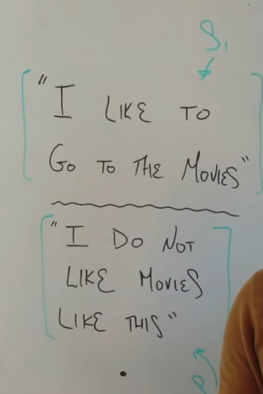

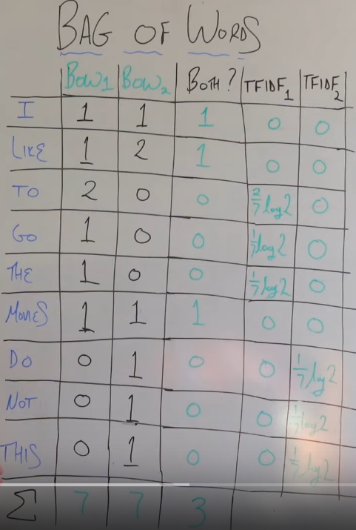

References  
<https://www.tutorialspoint.com/python/string_maketrans.html>

<https://www.youtube.com/watch?v=BotYLBQfd5M>